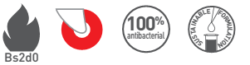
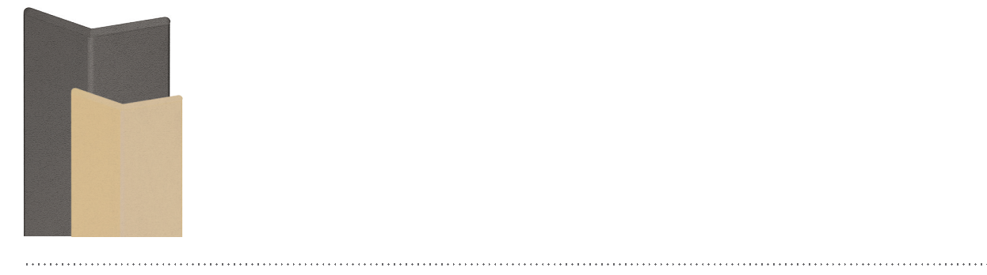
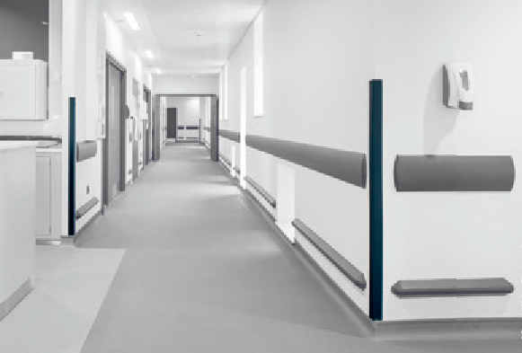

SPECIFICATION

COMBO’CORNER 75 AND 50
90° CORNER PROTECTORS ON ALUMINIUM CORE

- Description: 90° corner protector on aluminium core (Combo’Corner 75 or 50 as manufactured by SPM) from smooth or slightly textured (Optimixt grain as manufactured by SPM) and antibacterial PVC, 2 mm thick, achieving Bs2d0 fire rating with solid colour. Wings are 68 mm or 46 mm wide (internal measurement) and snap-fix onto a continuous aluminium core. The corner protector is finished with a slightly textured PVC endcap.
- Environment: no heavy metals and no substance potentially subjected to any REACH restriction are used in its manufacture, nor PBT/BPA. The calcium-zinc thermal stabilization process is used. The emission level of volatile substance in inside air has been tested according to ISO 16000-6 and is very low (A+) according to the French regulation (23 March 2011 nr 2011-321 Decree and 19 April 2011 Order). 100% of the product are recyclable.
- Colour: selected by architects from manufacturer’s standard range.
- Installation method: snap-fixes onto continuous aluminium core screwed to the wall.
